**Department of Electronics & Communication Engineering**

**National Institute of Technology Karnataka**

Surathkal, Mangalore-575025(Karnataka), India

**EC460- Image Processing and computer Vision**

# Assignment 3: Module 2

**Issue date: 23-11-2021 Submission date: 30-11-2021**

Q.1. Write and proof the various properties related to 2D Discrete Fourier Transform.

( Note: submit scanned copy of solution in single pdf file)

Q.2. Write python from scratch for computing 2D DFT{X(k,l)} of the following 2D array

(a) x(m,n) = np.array([[1, 0],[2, 1]])

(b) x(m,n) = np.array([[1,2, 3,4], [5, 6, 7, 8], [9,10,11,12], [13,14,15,16]])

Q.3.Write python from scratch for 2D Circular convolution using Doubly Block Circulant matrices method between input=np.array([[1,2,3],[4,5,6],[7,8,9]])and filter=np.array([[1,2,1],[0,0,0],[-1,-2,-1]])

Q.4. Write python code to compute 2D DCT for the 4x4 image **S** given below and reconstruct it using different masking windows to evaluate the effect of different basis images.

1. Determine the 2D-DCT coefficients, *Tk,l, k=0,1,2,3;l=0,1,2,3.*
2. Show that the reconstructed image from the original DFT coefficients equal to the original image.

$$S=\left[\begin{matrix}9 & 1 & 9 & 1 \\ 1 & 9 & 1 & 9 \\ 9 & 1 & 9 & 1 \\ 1 & 9 & 1 & 9\end{matrix}\right]$$

Q.5.

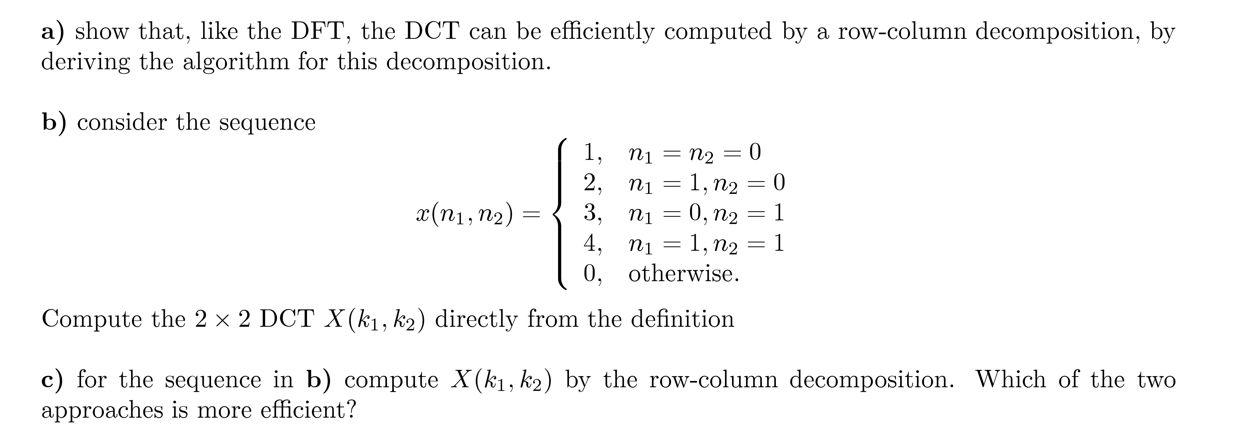

(Note: submit scanned copy of solution in single pdf file)